Name: Answer Here

ROMEO AND JULIET: DISCOVERY GUIDE

Introducing Romeo and Juliet
- WATCH FOR IT!
  - Take a minute to jot down what you already know about Romeo and Juliet. How much of the story have you already heard? Are there certain words or expressions that you associate with those two names? What overall impression do you have of the play, based on what you have heard, read, or seen?
    - Answer Here
If you don't know anything about the play, take a look at the images below. Jot down your impressions.
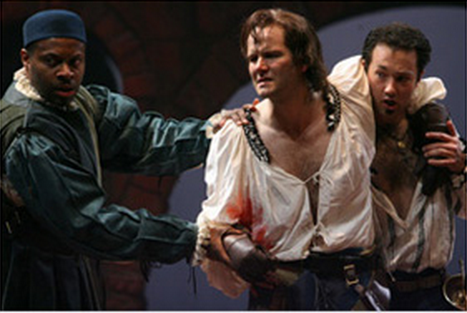
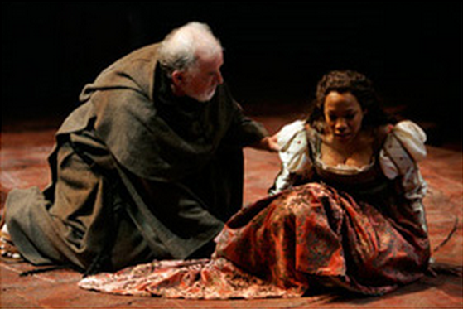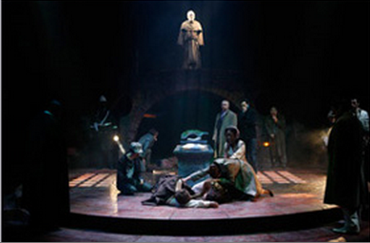
Answer Here
Keep these jot notes in your Drive or DropBox folder. You can revisit them after you’ve explored the story and see which of your ideas have changed, and which have stayed the same.

- TIPS AND QUESTIONS
  - Themes
    - Big Questions
One of the reasons Shakespeare’s plays are still being performed and read today is that they deal with timeless questions that everyone asks at some point in their lives, no matter when or where they live.

    - In Romeo and Juliet, you’ll be exploring questions such as the ones listed below. Jot down some thoughts about each of these questions explaining how you would respond to them right now.
What is love?
Answer Here
How can good intentions have bad consequences? (You mean to do well, but things turn out badly)
Answer Here
How much control do we really have over our lives?
Answer Here
How can we know if we are making wise/right decisions? What might they be based on?
Answer Here
Keep the questions in mind as you read the play. As we go through, we will uncover how the characters grapple with them. It’ll be interesting to revisit your responses once you’ve read the story, to see what new insights you’ve gained.
  - Characters
    - Character Connections
You could also draw a diagram for each main character to show how he or she is connected to others. Here's an example of a diagram started for Romeo.
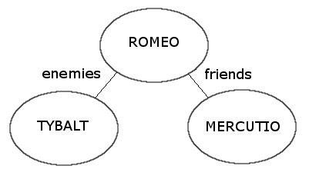
    - Montague or Capulet?
There are quite a few characters to keep track of in Romeo and Juliet. Most are connected with either the Capulet or the Montague household.
Try creating some kind of visual organizer to help you keep the characters straight. You might draw two houses and write the names of everyone associated with the Capulets in one, and those connected with the Montagues in the other. (You’ll have to find some way of incorporating characters that aren’t associated with either household, such as Prince Escales.) Or find your own creative way to keep everybody straight.
    - TIP! If you forget who a character is as you’re reading the script, you can always click on the name for a reminder, but it’s a good idea to familiarize yourself with who’s who sooner rather than later.

- MEDIA SPOTLIGHT
  - Costumes: Stratford Festival 2008
Browse through some of the costume images from the Stratford Festival 2008 production below. In this case, the director and costume designer have created both modern and period costumes for each character in the play.
- Benvolio in modern dress. | Benvolio in period costume.
 | 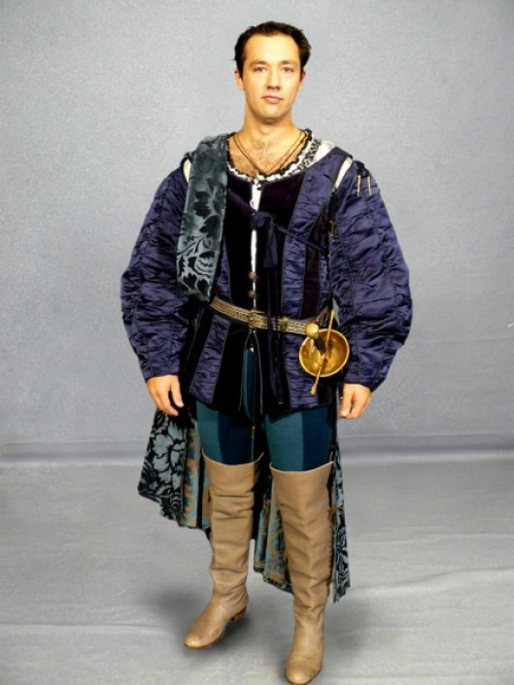
Capulet in modern dress. | Capulet in period costume.
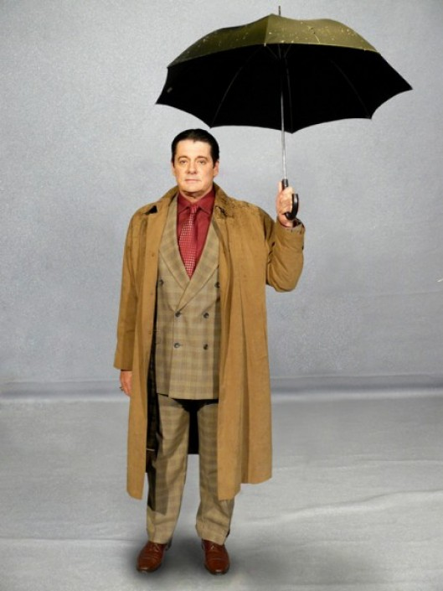 | 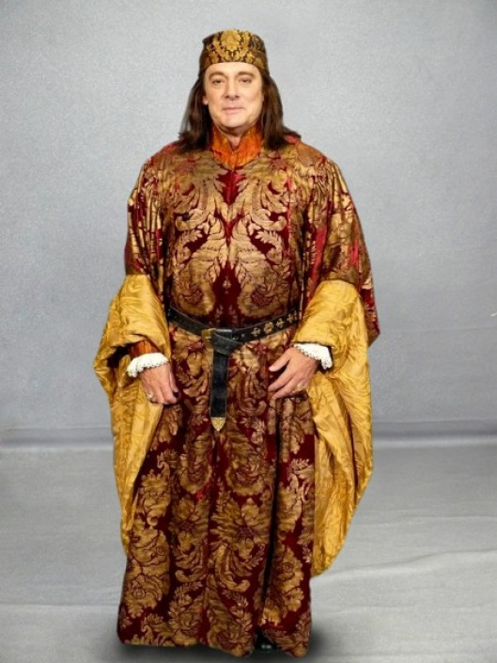
Juliet in modern dress. | Juliet in period costume
 | 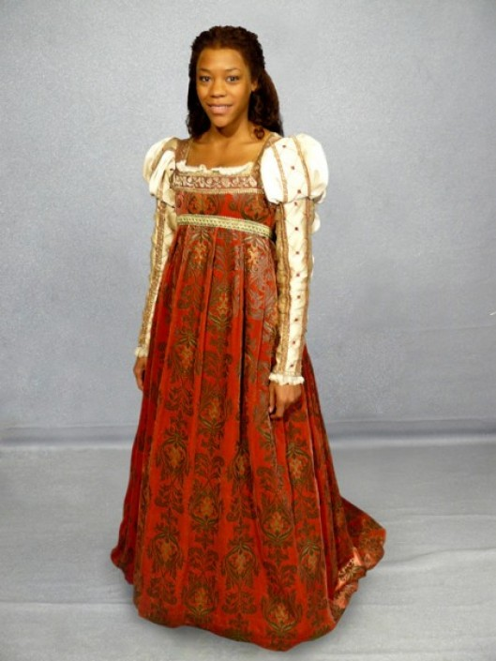
Romeo in modern dress | Romeo in period costume.
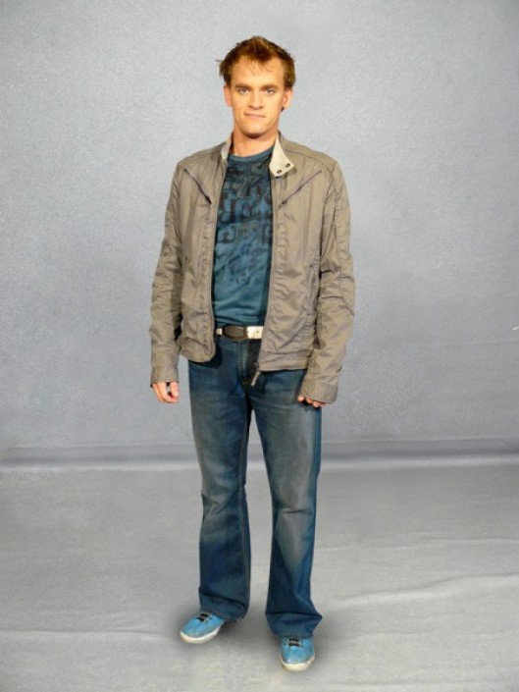 | 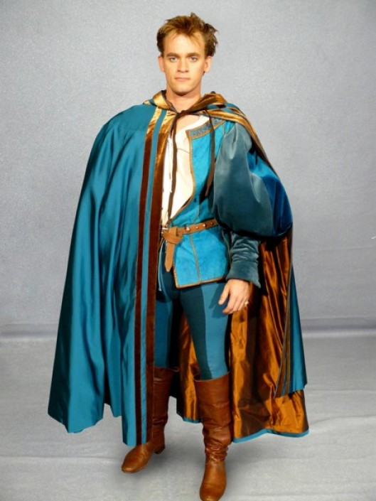
What connections do you notice between the two costumes for the same character? Answer Here
How do the colours, textures, or style of clothing remain connected, if at all? Answer Here
Why do you think a director would choose both types of costumes? Answer Here

