To Map a Story

Read the following story. Then look at the diagram and answer the questions below.

On a warm night in late summer, Nate awoke to what he thought were scratching noises just above his bedroom, on the roof. He waited. And when the noise stopped, he smiled to himself and thought his imagination had gotten the best of him. Against the advice of his older sister, he had stayed up late watching a few scary movies. Soon he fell back to sleep. Then it happened again. He heard it.

He was too embarrassed to go downstairs and tell his parents. And he certainly didn’t want to give his sister the satisfaction of knowing that he was scared, that maybe he shouldn’t have watched those movies. The scratching seemed to grow louder and louder. Nate sprang from his bed. Standing perfectly still in the middle of the room, he felt the pounding of his heart and his knees began to shake. Was that a shadow moving across the windowpane? He worked up the courage to move toward the window. He reached out, unlatched the lock and with eyes closed tight, opened it wide. Leaning his head out, he looked to the ground below. Nothing. Just then, right above him, he heard the slightest scratch. Up on the rooftop was a small branch of a large oak tree rubbing gently against the house. Nate gave a sigh of relief and returned to bed. He’d ask his father to cut down the tree in the morning.
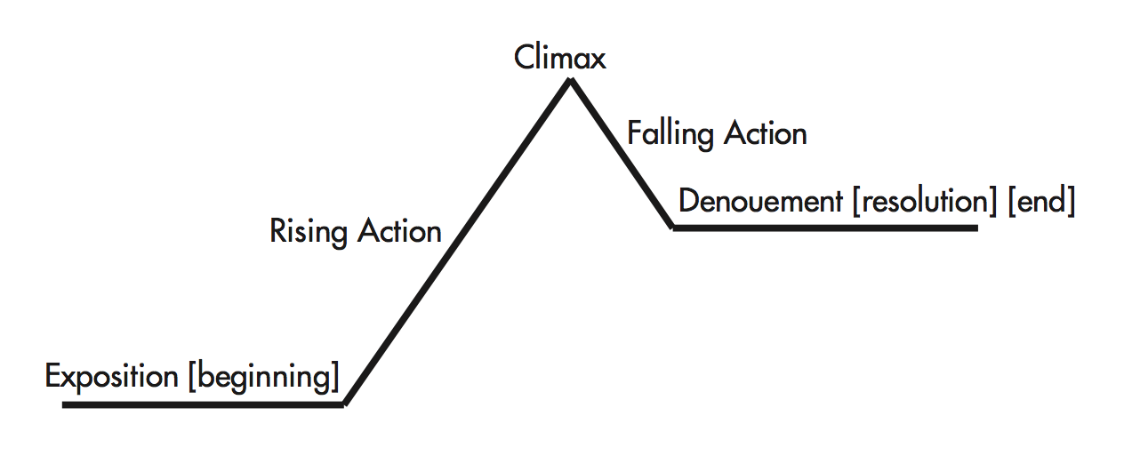
Climax

1. What is the introduction?

2. What is the rising action?

- What’s the problem or conflict?

b. What type of conflict is it?

3. What is the climax of the story?

4. What is the falling action?

5. What is the resolution?

